ASD TCPServer Developer’s Kit
Rev 1.0

This developer’s kit includes the following:

- ASD TCPServer Developer’s Guide
- A demonstration program written in “C” showing the implementation of typical spectrometer operations.
- A set of custom LabVIEW Virtual Instruments (VI) showing the implementation of several spectrometer commands and demonstrating the extraction and display of spectral data.
- A custom LabVIEW demonstration application incorporating the above VIs.

The Developers Guide is a comprehensive technical manual describing the ASDTCP Server command set. Each command is described in detail with all available parameter definitions, response data structure definitions and error code descriptions.

The demonstration programs are provided to give the developer examples of system command and response scenarios. The examples do not demonstrate all command or response capabilities of the ASD TCPServer but rather provide a “HOW-TO” for some commonly used operations.

The ASD FieldSpec 3 spectrometer incorporates an embedded control computer which performs the required communication, data collection and data formatting operations. This control computer and its associated firmware are referred to as the ASD TCPServer.

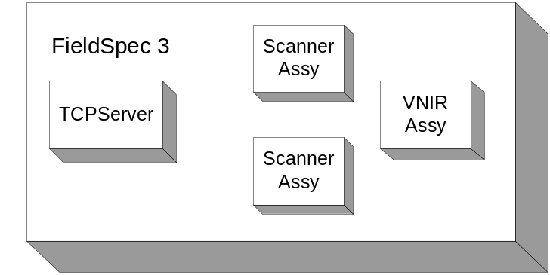

Communications with the ASD TCPServer is accomplished through a high-speed 10/100-Base-T Ethernet connection.

This design approach provides addition benefits to customers with special interface requirements, system integration issues or multiple spectrometer configurations. The software interface to the instrument has been greatly simplified for easy integration.

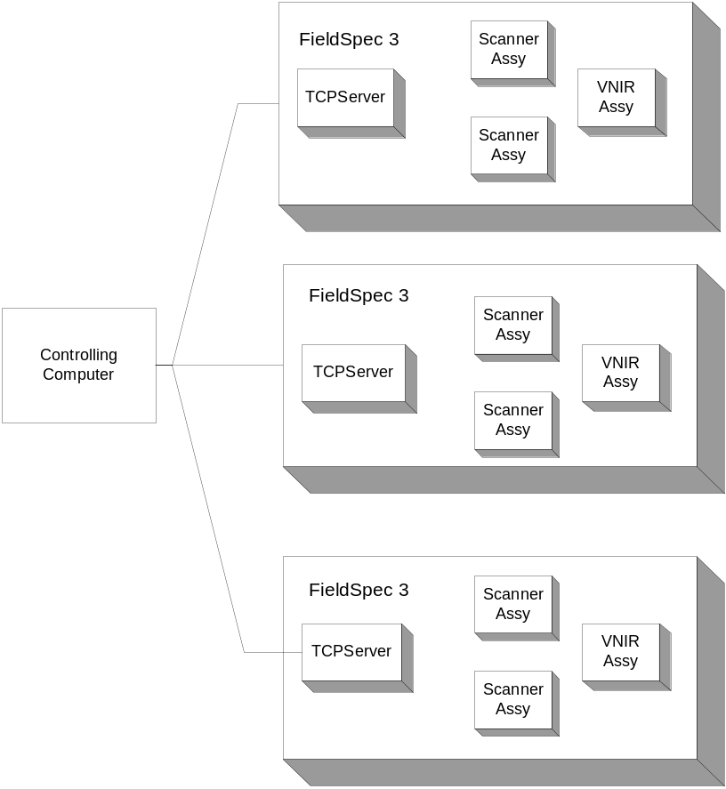

This developer’s kit will provide the necessary information to enable full control of the ASD spectrometer with any computer system capable of generating and receiving TCP/IP command strings. Applications are not limited to any particular computer language or system. Communications with the spectrometer system can be achieved with C, C++, Visual Basic, JAVA, LabView or any another language which allows access to the Ethernet adapter of the user’s computer.
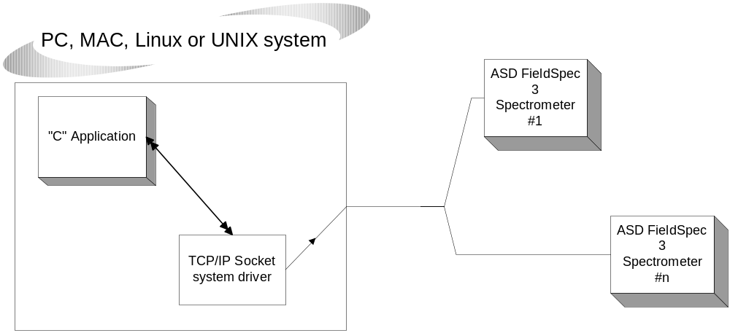

Also included in the developer’s kit are LabVIEW Sub-VI applications which demonstrate the collection of spectra, dark current correction and other operations. These can be easily integrated into your application and/or used as an example for creating your own Sub-VIs.

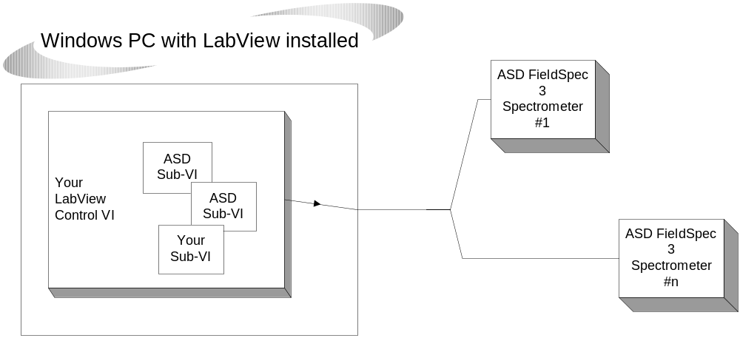

The “C” and LabVIEW example code is free to use in any of your applications but we make no representation, warranty, or claim that the information available here is current or accurate. Analytical Spectral Devices is not responsible for any errors or omissions in the resources or information whether available in this document, associated document or in any form whatsoever.

ANALYTICAL SPECTRAL DEVICES DOES NOT (A) MAKE ANY WARRANTY, EXPRESS OR IMPLIED, WITH RESPECT TO THE USE OF THE INFORMATION PROVIDED HEREBY; NOR (B) GUARANTEE THE ACCURACY, COMPLETENESS, USEFULNESS, OR ADEQUACY OF ANY RESOURCES, INFORMATION, SYSTEM, PRODUCT, OR PROCESS AVAILABLE - AT OR THROUGH ANALYTICAL SPECTRAL DEVICES.

